The Coffee Can - website content - words

History:

The Coffee Can started life in May 2014, Mr Can having had a long burning ambition to run a coffee van. After an extensive search of vans to buy, we made the decision to have our coffee van custom made for us at Bella Manufacturing on the Sunshine Coast. We had the van designed to our specifications and 4 years on, its out working practically 7 days a week.

The Coffee Can Cafe came about when we needed to make the choice of having another van or adding a brick and mortar shop to our portfolio. We took over the Corner Store on Michaelangelo, Redlynch in September 2017 and have not looked back since. The brick and mortar Cafe has added to our reputation for great coffee every time and excellent customer service and we now have a Coffee Can ‘Cart’ which we use at corporate events and as an additional platform for indoor bookings.

Staff: As well as owner Sharon and Chris, we now have Faloun who does the coffee van run and Deearn who runs the Cafe on a daily basis.

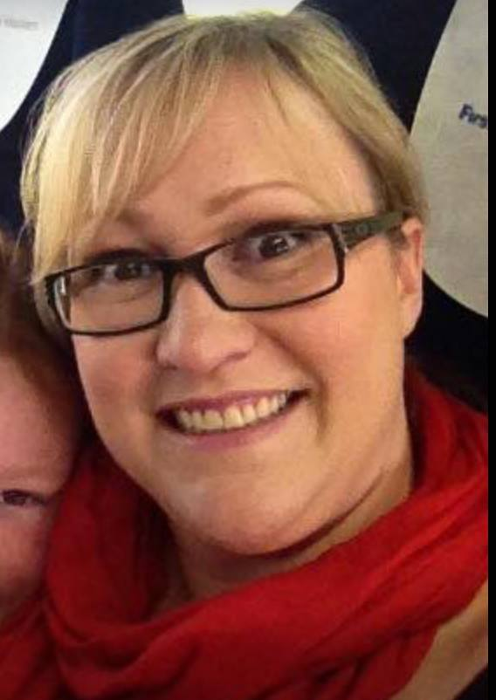

Bio’s:

Name : Sharon (the Boss Lady)  
Favourite Coffee: extra shot skinny FlatWhite  
Favourite Food: all of it!

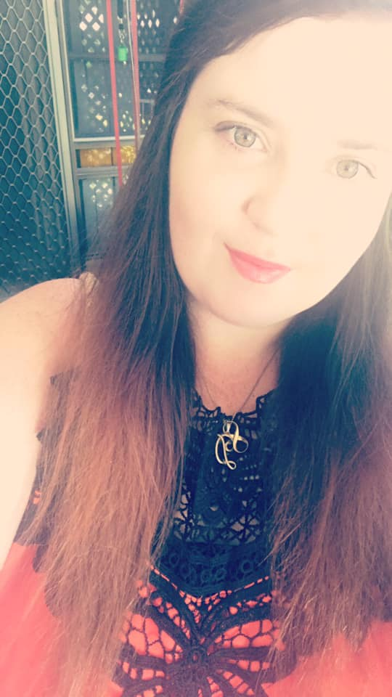

Deearn: (Manager)

Fav coffee: caramel Latte

Fav food: banana bread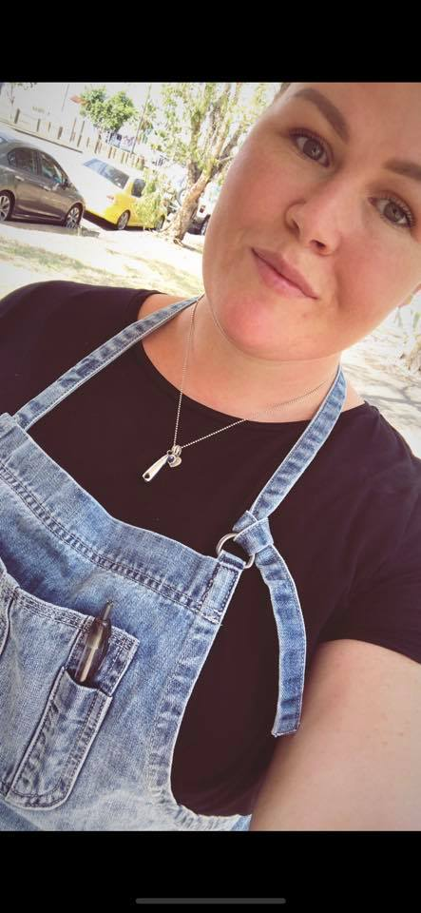

Name: Fal (boss lady’s unicorn 🦄 )

Favourite coffee: Iced latte (strong)

Things I’m good at: droppin shots, spinnin milk and running my mouth.

Favourite food: everything I’m not aloud to have 😎

Coffee: Our Coffee Beans are roasted locally in Cairns at the White Whale Coffee Roasters. It is an exceptional blend that is consistent all year round and stands up to the local creamy Mungalli Milk that we use in all our coffees. We serve a double shot as standard and a triple in our large coffee’s.

The Barista Blend we use is super smooth with notes of hazelnut & milk chocolate with a long sweet finish.

* *see ‘Coffee Can Because' document for more details about our ingredients and products.*
* *see ‘Wedding Leaflet for details of our ‘Coffee Cart’ service.*

The Coffee Can has serviced events with up to 10,000 people attending, nothing is too big or small if we have the availability. We are also able to cater for your work meetings, Expo’s, Birthday’s and Special Occasions from our Cafe in Redlynch.

Types of events we have previously done…..

Coffee and Drinks:

Festivals, Racing Meets, Birthdays, Wedding Reception, Charity Events, Sporting events, Work Meetings, Fetes, School Carnivals, Concerts, Markets, Workplace coffee, Conferences

Catering and Drinks:

Expo’s, TV Crews, Club Meets, Birthdays, Funerals.